**Assessment 1 - Intro & Data type**

**Email address:**

**Write your name:**

**1.** What will be the output statement of this code? (3 points)



* Hello World
* "Hello World"
* 'Hello World'

**2.** What will be the output statement of this code? (3 points)

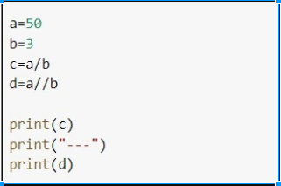

* 16.6666668 --- 16.6666668
* 16 --- 16.6666668
* 16.6666668 --- 16
* 16 --- 16

**3.** Is 2*2 and 2**2 same on python? (2 points)

* Yes
* No

**4.** What version of python will we learn throughout this session?

(2 points)

* Python 1.x
* Python 2.x
* Python 3.x

**5.** What will be the output statement of this code? (5 points)

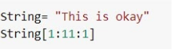

* 'his is okay'
* 'hsi ky'
* 'This is okay'
* 'his is oka'